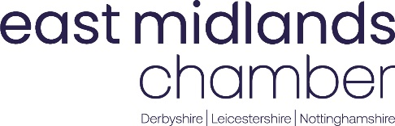
QUALITY POLICY STATEMENT

It is the policy of East Midlands Chamber (Derbyshire, Nottinghamshire, Leicestershire) (the Chamber) to provide membership and commercial services, training, consultancy, and property and facility services that consistently meet the goals, expectations and needs of our members and customers.

In support of our aims and strategic direction and to demonstrate our commitment to quality, we operate an Integrated Management System in accordance with the requirements BS EN ISO 9001:2015, the requirements of our members and clients and in accordance with our compliance obligations.

We will review the risks and opportunities to our business and set objectives against which our performance can be measured to identify opportunities for continual improvement of the Integrated Management System and enhancing levels of member and client satisfaction.

All personnel shall comply with the requirements of the Chamber Integrated Management System and when possible shall consider improvements that can be made to processes.

The only way to achieve and maintain this policy is for every employee, in whatever capacity to perform his or her work to the required standards at all times.

The aim must be to:

GET IT RIGHT FIRST TIME, EVERY TIME, AND STRIVE FOR CONTINUAL IMPROVEMENT.

This policy will be reviewed annually as part of the management review process, to ensure its continued relevance and adequacy.

It is part of the Chamber induction programme for all employees to ensure that this policy statement is understood and implemented at all levels within the organisation.

This policy is available to interested parties via the Chamber website.

This policy has been approved by the Chief Executive. Signed:
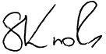
Title: Chief Executive Date: January 2024

Document Ref: 700 Page 1 of 1

