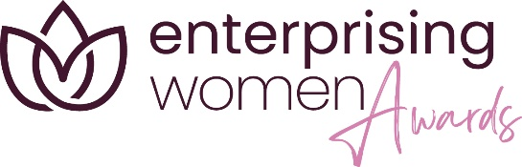

Enterprising Women Awards 2024
Application Guidelines

Thank you for entering the East Midlands Chamber (Derbyshire, Leicestershire, Nottinghamshire) Enterprising Women 2024 Awards. Before completing your application form, please read these entry guidelines carefully. Failure to do so may result in an invalid entry.

- The Chamber’s Enterprising Women Awards 2024 are free to enter and only open to members of East Midlands Chamber (Derbyshire, Leicestershire, Nottinghamshire). Entries are treated in confidence but will be shared with a select group of individuals for judging purposes.

- Please note the maximum word count for any entry is 2,000 words (except for the Lifetime Achievement Award which has 1,500-word limit). This word count limit does NOT include the questions or administrative information. If your entry exceeds this word count it could be disqualified by the judges. Entries must be sent electronically via email to events@emc-dnl.co.uk and saved as a word document.

- Supporting information is not permitted unless it forms part of the entry document e.g. testimonials. A maximum of 2 insertions (e.g. tables, graphs or photos) may be included within the entry form.

- Please be aware that any web links used within your entry will not be activated by the judges. Supplementary information may be requested, and entrants may be asked for staff or customer testimonials. The judges’ decision is final, and no further correspondence will be entered into. Entrants can request feedback on their application.

- All entrants will be invited to attend a finalist event in June 2024 where the Enterprising Women co-chairs will reveal the finalists for each category. *Please note this will be in-person. All finalists will be notified of the announcements whether they attend the event or not.

- All finalists will be invited to take part in a virtual judging session which will allow each finalists a strict 10-minute appointment to meet with category sponsors and judges. (Exact date TBC – but the team intend this to take place in early July)

- Winners will be announced at the Enterprising Women Awards ceremony on Friday 20th September 2024.

- Please be aware where indicated in the entry form an overview will be taken and shared with the Chamber’s Marketing Department. This will be used in marketing activity such as event programmes. Please make sure you are entirely happy with the content when submitting the entry as the Chamber will not be responsible for correcting errors.

- Applicants must be authorised to enter their organisation into the awards programme. Entry to more than one category is permitted.

- All entries will be acknowledged on receipt (proof of sending entry is not proof of receipt).

- Please ensure that all submitted entries are final. The Chamber will not check applications for completeness or validity.

- The Chamber reserves the right to withdraw an award from any applicant supplying false information within their entry.

- Any entrant wanting support or advice in completing their award application, should contact the Chamber Enterprising Women team on 0333 320 0333.

- The deadline for entries is 5pm on Friday 10 May 2024

Top five hints and tips for completing your application:

1. Provide clear workplace examples backed up by facts and figures to illustrate your achievements
2. Use your application to tell a passionate story of your business and/or role. Describe what makes you unique?
3. Read the application award criteria and questions carefully and apply your direct experience to it.
4. Do not use language as a barrier to the reader. Keep it clear, concise and avoid technical references/jargon.

5. Get a colleague to read the application before it is submitted. A fresh pair of eyes can spot things that you may not, and consultation with colleagues can add real value.

