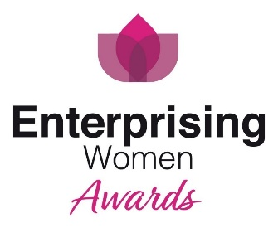
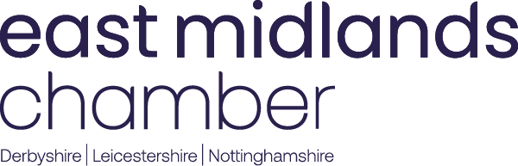

Enterprising Women
Small Business of the Year 2024
Application Form
Sponsored by Unique Window Systems
This award aims to recognise women who own or manage a small organisation and employ up to 50 employees. The award will go to the company which has achieved consistent growth backed by a strong financial performance.

Thank you for your interest in applying for the East Midlands Chamber (Derbyshire, Nottinghamshire, Leicestershire) Enterprising Women Small Business of the Year award 2024. These awards celebrate and showcase the successes of women in business that have taken place in the East Midlands region over the past year.

To support a valid entry, before completing this application please carefully read the accompanying guidelines for applying.

Please note: Applications have a strict 2,000 word limit. This document currently contains 627 words which consists of instructions and questions. Therefore, the total word count of this entire document once completed must be no more than 2627 words.

A maximum of 2 attachments (e.g., tables, graphs or photos) may be included with the entry form. These attachments must be image files (jpg, gif, png or tif) and must not exceed 5MB in total. Any attachments that exceed the permitted allowance or exceed the permitted file size will be deleted.

Please save your completed form as a word document using the format yourcompany_awardcategory.doc (Example: East Midlands Chamber_Employer of the Year.doc) and email to events@emc-dnl.co.uk. The closing date is Friday 10 May 2024. The Chamber and Enterprising Women team look forward to receiving your entry and wishes you the best of luck.

TOTAL WORD COUNT

Contact name
Name of entrants
Company name
Company address
Email address
Web site address
Telephone number
Twitter account
Business sector
Nature of business
Main product/service
Number of employees
Chamber Membership Number

*These must be completed | FY 2020 | FY 2021 | FY 2022
Turnover*
Net Profit*
Reserves*

- Please provide a brief description of the business, the products or services it supplies, its customers and the markets that it operates in.

You should cover:
- The nature of your business and its history, including when the business started trading.
- Your products and services
- Your customers and markets that you operate in
- How does your business differ from that of your competitors
- Reason for entering into the Enterprising Women Awards

PLEASE NOTE: This description will be provided as an overview to the East Midlands Chamber marketing team. Should you be successfully shortlisted as a finalist the description provided below will also be used in any marketing activity including event programmes and finalist videos. Please ensure you are entirely happy with the content on submission as the Chamber cannot be held responsible to make amendments.
(Please complete in no more than 250 words)

- Please describe your organisation’s achievements since starting the business and how these were accomplished?
You should cover:
- The business’ achievements
- How these achievements were accomplished
- Details of any changes you have implemented or decisions that you have made which have directly influenced the business and the results
- The affect that these achievements have had on the future of the business

- Please outline the overall trend in your sales turnover and profit development together with a brief description of any key events that have led to any changes, where appropriate.
You should cover:
- How your sales turnover has developed
- How your profit has developed
- Any events that have led to any changes. Please provide an explanation.

- What objectives have you set for the business over the next three years and how will these be achieved?
You should cover:
- Main objectives for the next three years
- How will these be achieved
- Effects that these will have on the overall business

5. Please describe why you think your company should win the Small Business of the Year award?

