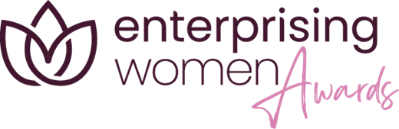
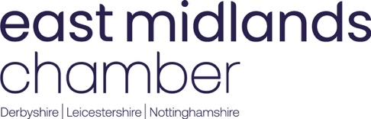

Enterprising Women Female Employee of the Year 2026
Sponsored by Cambridge & Counties Bank
Closing Date: 22nd May 2026, 5pm

This award aims to recognise a woman that has made a significant difference to their organisation. This person will not own or run the business, but will have contributed to its overall success over the past 12 months by going the extra mile.
The entrant must demonstrate how they have contributed to their organisation, giving examples of their impact.

Instruction
Thank you for your interest in applying for the East Midlands Chamber (Derbyshire, Nottinghamshire, Leicestershire) Enterprising Women Awards 2026. These awards celebrate and showcase the successes of women in business that have taken place in the East Midlands region over the past year.

To support a valid entry, before completing this application please carefully read the accompanying guidelines for applying.

Please note: Applications have a strict 2,000 word limit. This document currently contains 785 words which consists of instructions and questions. Therefore, the total word count of this entire document once completed must be no more than 2785 words.

A maximum of 2 attachments (e.g., tables, graphs or photos) may be included with the entry form. These attachments must be image files (jpg, gif, png or tif) and must not exceed 5MB in total. Any attachments that exceed the permitted allowance or exceed the permitted file size will be deleted.

Please save your completed form as a word document using the format yourname_yourcompany__awardcategory.doc (Example: JaneDoe_EastMidlands Chamber_Employee of the Year.doc) and email to events@emc-dnl.co.uk.

The closing date is 5pm on 22nd May 2026.

The Chamber and Enterprising Women team looks forward to receiving your entry and wishes you the best of luck.

TOTAL WORD COUNT

Contact name (if nominating on behalf of someone)
Contact email address (if nominating on behalf of someone)
Name of entrant(s)
Company name
Company address
Entrant Email address
Website address
Telephone number
LinkedIn account
Business sector
Nature of business
Main product/service
Number of employees
Chamber Membership Number

1. Give an overview of your/the entrant’s career to date
You should cover:
- The nature of your business, along with products and services
- The market in which your business operates
- How long you have been in your current role and what it involves
- Any developments in your role since you have been working in the organization
- How your organisation demonstrates innovation and best practice
PLEASE NOTE: This description will be provided as an overview to the East Midlands Chamber marketing team. Should you be successfully shortlisted as a finalist, the description provided below will also be used in any marketing activity including event programmes and finalist videos. Please ensure you are entirely happy with the content on submission as the Chamber cannot be held responsible to make amendments.

(Please answer in no more than 250 words)

2. Please describe the unique skills or methods that you/the entrant have brought to the business? E.g. idea generation, relationship building, working style etc.
You should cover:
- The ways in which you feel you/the entrant has brought something different to the business
- Details of any outcomes that have been implemented as a direct result of your/the entrant’s contribution
- How you/the entrant uses their own initiative to deliver results
- The applicant's ability to work collaboratively, motivations and enthusiasm for their role within the business

3. Demonstrate how you/the entrant shows resourcefulness and adaptability
You should cover:
- How you have overcome a particular challenge at work
- Examples where you/the entrant have gone the extra mile, above and beyond normal duties
- How the applicant uses their own initiative to deliver results

4. Please describe why you think you/the entrant should win the Enterprising Women Female Employee of the Year award?

